FRESHERS SALARY DASHBOARD
ABSTRACT
This project, Indian Freshers Salary Dashboard, presents a comprehensive analysis of salary trends for fresh graduates in India using a structured dataset and an interactive dashboard. The project focuses on understanding salary distribution based on job roles, company types, individual companies, and internship stipends. By leveraging data analytics and visualization techniques, the dashboard provides meaningful insights that help students, job seekers, and recruiters understand fresher salary patterns in the Indian job market
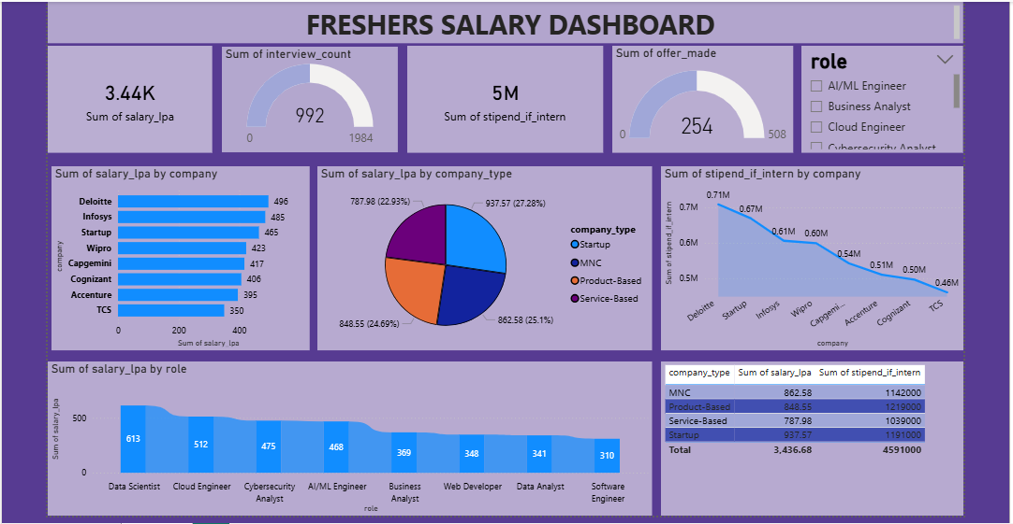

INTRODUCTION
In today’s competitive job market, fresh graduates often face uncertainty regarding expected salaries, suitable roles, and company preferences. Data-driven insights can reduce this uncertainty by highlighting real-world salary trends. This project analyses Indian fresher salary data and presents it through an interactive dashboard, enabling users to explore salaries, interview counts, offers made, and internship stipends across different dimensions such as role, company, and company type.

OBJECTIVE OF THE PROJECT
The main objectives of this project are:
- To analyse salary trends of Indian freshers across different job roles
- To compare salaries offered by various companies and company types
- To evaluate internship stipend distributions
- To identify high-paying roles and organizations for fresh graduates
- To present insights using an interactive and easy-to-understand dashboard

DATASET SUMMARY
The dataset used in this project contains information related to fresher employment in India. Key attributes include:
- Role – Job roles such as Data Scientist, Cloud Engineer, Business Analyst, etc.
- Company – Hiring organizations like Deloitte, Infosys, TCS, Accenture, etc.
- Company Type – Startup, MNC, Product-Based, and Service-Based companies
- Salary (LPA) – Annual salary offered to freshers (in Lakhs Per Annum)
- Interview Count – Number of interviews conducted
- Offer Made – Number of jobs offers issued
- Internship Stipend – Monthly stipend offered to interns
The dataset is clean, structured, and suitable for analytical and visualization purposes.

DASHBOARD EXPLANATION
The dashboard provides an interactive view of fresher salary trends using KPIs and charts:
KPI Cards
- Total Salary (3.44K LPA) – Cumulative salary offered across companies
- Interview Count (992) – Total number of interviews conducted
- Internship Stipend (5M) – Total stipend amount for interns
- Offers Made (254) – Total job offers provided
Charts and Visuals
- Salary by Company (Bar Chart): Shows companies like Deloitte and Infosys offering higher total salaries
- Salary by Company Type (Pie Chart): Compares Startup, MNC, Product-Based, and Service-Based companies
- Internship Stipend by Company (Line Chart): Highlights companies providing higher internship stipends
- Salary by Role (Bar Chart): Indicates that Data Scientists and Cloud Engineers receive higher salaries
- Filters (Slicers): Role-based filtering allows users to analyse specific job roles

KEY LIMITATIONS
- The dataset represents a limited sample and may not reflect the entire Indian job market
- Salary figures are aggregated and may hide individual-level variations
- Location-based salary differences are not included
- Real-time data updates are not available

INSIGHTS
- Data Scientist and Cloud Engineer roles receive the highest salary packages among freshers
- MNCs and Product-Based companies offer better salary packages compared to service-based firms
- Deloitte and Infosys are among the top contributors to fresher salaries
- Internship stipends vary significantly across companies, with top firms offering higher stipends

FUTURE ENHANCEMENTS
- Include location-wise salary analysis (city/state-level)
- Add experience level comparison (intern vs fresher vs experienced)
- Integrate real-time or live data sources
- Implement predictive analytics for future salary trends
- Deploy the dashboard as a web-based application

CONCLUSION
The Indian Freshers Salary Dashboard successfully demonstrates how data analytics and visualization can provide valuable insights into fresher salary trends. This project helps students and job seekers make informed career decisions and showcases practical data analytics skills using real-world data. It also highlights the importance of dashboards in simplifying complex datasets into actionable insights.

REFERENCES
- Microsoft Excel Documentation
- Data Analytics and Visualization Learning Resources
- Publicly available fresher salary datasets
- Online articles on Indian IT and analytics salary trends

